CONTEXT

The purpose of this project is to run a traffic simulation in a 3D environment. The code should be able to gather data from<https://www.openstreetmap.org/>

and after downloading the data, converting it to a txt file, render the map into the 3D environment.

OVERVIEW

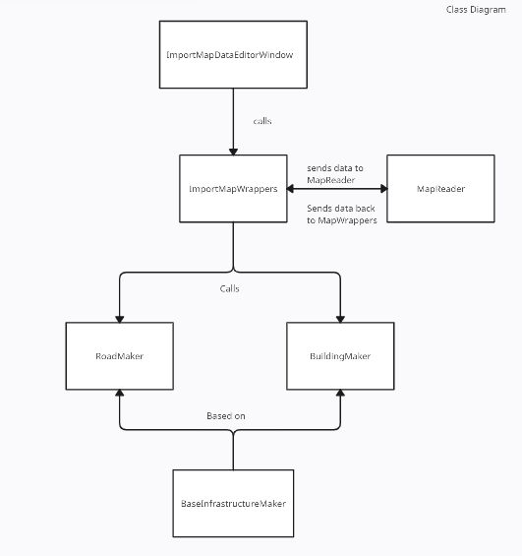

GOAL

The goal for this semester was to be able to render in OpenStreetMap data into a 3D environment.

We also added a way to drop a car into the environment, and have it follow a set route.